**The Generic CoA – SBR and more**

Started the day with working on BROS – CoA section. Specifically these lines



Whilst this is not intrinsically wrong, it is inadequate.

There are many other elements which could be classified under Other Operating Income.

The Hys 38 (New DPL) could be used, but it has common Dimension issues.

So could at a push merely add other CoA rows, and merely decide which Set (Row 10004 or 10005 they should go under).

Then thought to investigate SBR looking very much for aspects that would help in the area of CoA.

The Definition Taxonomy does not have a Calculation Network (though there is a Relationship tab).

[http://bigfoot.corefiling.com/yeti/resources/yeti-gwt/Yeti.jsp#tax~(id~102*v~159)!net~(a~1159*l~379)!lang~(code~en)!rg~(rg~1*p~1)](http://bigfoot.corefiling.com/yeti/resources/yeti-gwt/Yeti.jsp#tax~(id~102*v~159)!net~(a~1159*l~379)!lang~(code~en)!rg~(rg~1*p~1))

And it is obviously covers GL type information. Though with some oddities such as why there is both an entry for *Expense Bad and Doubtful Debts Amount* and Expense Bad and Doubtful Debts Amount and Provision for Doubtful Debts Amount. This would have made sense if former was a child of the latter (plus another line just for Provision of Doubtful Debts). But there is not as can be seen by the relationship tab. See table below.

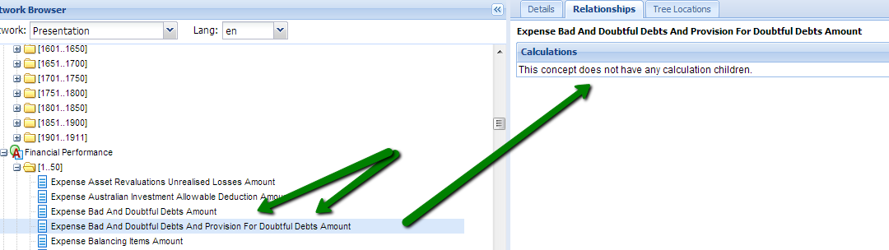

The older Australian SBR Cycle 1 prototype does have both Presentation and Calculation. However it is so form focused that it is not easy to extract a coherent CoA. In fact one cannot be sure that there is one to extract.

[http://bigfoot.corefiling.com/yeti/resources/yeti-gwt/Yeti.jsp#tax~(id~67*v~75)!net~(a~621*l~229)!lang~(code~en)!rg~(rg~1*p~1)](http://bigfoot.corefiling.com/yeti/resources/yeti-gwt/Yeti.jsp#tax~(id~67*v~75)!net~(a~621*l~229)!lang~(code~en)!rg~(rg~1*p~1))

In looking at the Australian SBR, looked at a number of possibly related or relevant documents:

Have posted various documents to /Braiins/Info/SBR folder.

In addition some direct links to the material below:

<http://www.auasb.gov.au/admin/file/content102/c3/Bulletin_June_2010.pdf>

The ASIC give a lot more detail than our authorities:

<http://www.asic.gov.au/asic/asic.nsf/byheadline/For+users+of+financial+reports?openDocument>

<http://www.asic.gov.au/asic/asic.nsf/byheadline/What+books+and+records+should+my+company+keep%3F?opendocument>

PET (Plain English Taxonomy)

Feel sure that this should be very useful, but not quite sure how.

<http://www.apra.gov.au/sbr-pet/concepts/concepts.html>

<http://www.apra.gov.au/sbr-pet/ARF/ARF_396_0_1-XBRL.html#DE19>

**Harmonisation, XBRL and the SBR Taxonomy**

<http://www.sbr.gov.au/about-sbr/publications-and-resources/learning-modules/harmonisation,-xbrl-and-the-sbr-taxonomy>

**Some MYOB links**:

<http://search.myob.com.au/accounting/Standard%20Business%20Reporting>

Is AccountRight compatible with the Standard Business Reporting (SBR) initiative?

<http://myobaustralia.custhelp.com/app/answers/detail/a_id/32250>

<http://myob.com.au/products/small-business/add-on-solutions/standard-business-reporting/govdirect-1257829896835>

Common Ledger

<http://myob.com.au/products/accounting-practices/client-accounting/ae-client-accounting-1258090694741?productArea=FeaturesAndBenefits>

**GovDirect**

<http://www.govdirect.com.au/about.html>

<http://www.govdirect.com.au/business.html>

<http://www.govdirect.com.au/pricing.html>

**GovShare**

Copy of this document on /Braiins/Info/SBR folder <https://govshare.gov.au/xmlui/handle/10772/6433>

Introduction paragraph from above

*The Government Information Exchange Methodology (GIEM) provides agencies with a suite of tools and methods to help them produce rigorous data exchange specifications for their specific project needs. GIEM is not a data standard in itself, rather it is a method to help leverage the plethora of (often overlapping) national and international standards in order to address specific interchange needs. GIEM comprises three documents:*

* ***GIEM Development Methodology*** *describes how to produce an interchange specification. It provides standard modelling templates and includes worked examples.*
* ***GIEM Naming & Design Rules*** *(this document) ensures that interchange specifications are consistent across projects. It provides rules for naming of data elements, namespaces, and XML schema design rules.*
* ***GIEM Governance Framework*** *provides confidence and trust in the interchange specification. It describes a set of standard project roles, describes the steps in the development process, provides voting rules & issue resolution procedures, and defines a conformance testing framework.*

<https://govshare.gov.au/xmlui/handle/10772/6428>

<https://govshare.gov.au/xmlui/handle/10772/6432>

AGIMO (Australian Government Information Management Office)

<http://agimo.gov.au/files/2013/01/APS_ICT_Strategy.pdf>

<http://agimo.gov.au/policy-guides-procurement/australian-government-architecture-aga/aga-rm/2-reference-model-overview/>

**UML**

The Unified Modeling Language™

<http://www.uml.org/>

Put in the above link because noted that it was referred to in some of the SBR documents.

**Taxonomies**

Finally today started looking at IFRS and US GAAP. Found that they both have Calculation networks. (So presumably the US Authorities do not find it too difficult to develop and maintain this in contrast to the UK Authorities).

Might not seem directly relevant, but it is easy to find documents comparing US and UK GAAP.

IFRS - Presentation

[http://bigfoot.corefiling.com/yeti/resources/yeti-gwt/Yeti.jsp#tax~(id~1*v~241)!net~(a~3*l~1)!lang~(code~en)!rg~(rg~1*p~1)](http://bigfoot.corefiling.com/yeti/resources/yeti-gwt/Yeti.jsp#tax~(id~1*v~241)!net~(a~3*l~1)!lang~(code~en)!rg~(rg~1*p~1))

IFRS – Calculation

[http://bigfoot.corefiling.com/yeti/resources/yeti-gwt/Yeti.jsp#tax~(id~1*v~241)!net~(a~4*l~2)!lang~(code~en)!rg~(rg~1*p~1)](http://bigfoot.corefiling.com/yeti/resources/yeti-gwt/Yeti.jsp#tax~(id~1*v~241)!net~(a~4*l~2)!lang~(code~en)!rg~(rg~1*p~1))

US-GAAP – Presentation

[http://bigfoot.corefiling.com/yeti/resources/yeti-gwt/Yeti.jsp#tax~(id~100*v~234)!con~(id~850361)!net~(a~1124*l~369)!lang~(code~en-us)!path~(g~13706*p~0_0_1_0_0_0_0_0_0_0_0_0_0_0_15_0)!rg~(rg~1*p~1)](http://bigfoot.corefiling.com/yeti/resources/yeti-gwt/Yeti.jsp#tax~(id~100*v~234)!con~(id~850361)!net~(a~1124*l~369)!lang~(code~en-us)!path~(g~13706*p~0_0_1_0_0_0_0_0_0_0_0_0_0_0_15_0)!rg~(rg~1*p~1))

US-GAAP – Calculation

[http://bigfoot.corefiling.com/yeti/resources/yeti-gwt/Yeti.jsp#tax~(id~100*v~234)!con~(id~850361)!net~(a~1125*l~372)!lang~(code~en-us)!rg~(rg~1*p~1)](http://bigfoot.corefiling.com/yeti/resources/yeti-gwt/Yeti.jsp#tax~(id~100*v~234)!con~(id~850361)!net~(a~1125*l~372)!lang~(code~en-us)!rg~(rg~1*p~1))

So task to start tomorrow (Tuesday 5th) is to investigate these US taxonomies.

Tuesday 5th February

# US Taxonomies

The examination was primarily in the area of Income and Expenses.

## Observations

1. Both taxonomies provide much more detail in the P&L/Comprehensive Income Statement than their UK equivalents. (And suspect also in every other area)
2. The fact that that both US GAAP and IFRS have Calculation Networks makes it much easier to work out which Elements should be considered as CoA/DE rows, and which should be considered

## Calculated Values

These can be viewed through the Calculation Network, or from the Presentation Network (or indeed from the DefinitionLink: Dimension-Member), using the Relationships tab. See example below from IFRS, Revenue

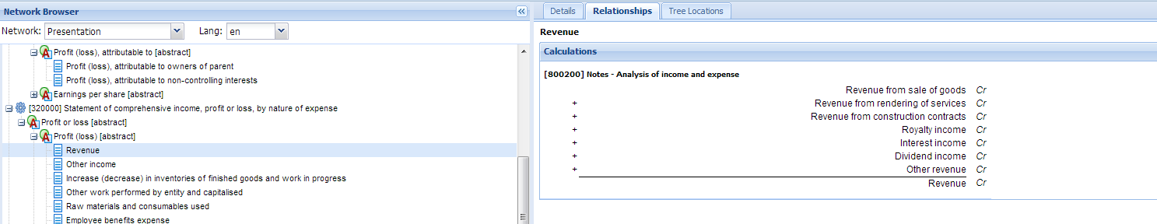

## The “Chart of Accounts” CoA

The US GAAP in particular yields what I would consider to be a very comprehensive Chart of Accounts. To such an extent that a User could transfer data to and from a general accounting program and be able to main high level of fidelity

Example:

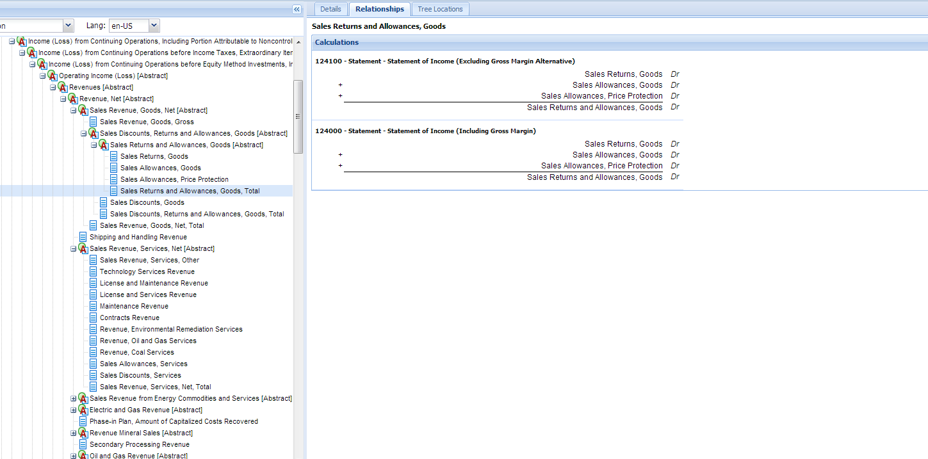

This does of course raise the question of how far do we want BROS to replicate a proper CoA, and how far do we just wish it to be able to allocate one or more lines from a source Import and put them into the right Bros/TxId element.

It would be useful if we want to:

1. Use this as at least the starting point in some generic global program.
2. Single taxonomies - a CoA which can handle any one taxonomy but is not just a slave to it.
3. Multiple taxonomies - Related to the above, having a proper CoA structure that can be taken as a general framework would make it easier to deal with other taxonomies in due course, even if each BrosTree worked with only one XBRL Taxonomy.
4. Wanted to provide more than just regulatory information. If we want to look a bit beyond mere regulatory disclosure, but to something more akin to proper inter-entity comparison, then this is another advantage of putting in a “proper” CoA, rather than just the barest required to satisfy the UK GAAP taxonomy. For example rather than just show net revenue, TxId 4907, one might like to show some part of it e.g. The “CoA” granulation in the US GAAP would allow inter-firm comparison of returned goods as a percentage of total goods sold (subject to some common BRT or XBRL label of course). See previous table.

If we put in NL Accounts for which there was no TxId at that level i.e. there is further up the tree, then we would need to put in the Dimensions that make up the TxId. But that of course we can do with Allow Dims.

Note that for the IFRS taxonomy there is even a link back to both the references and often also examples.

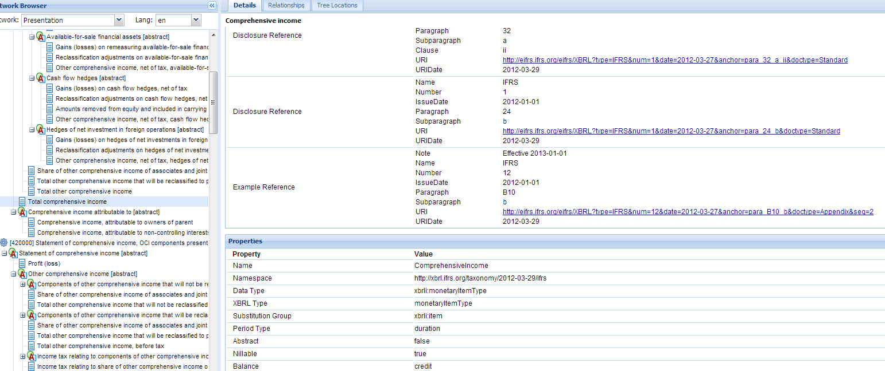

The only snag is that to access the links one must be a Subscriber, not just a Registered User as I am at the moment. The annual cost to be a subscriber is £210 for eFRS Online (or £475 for the Comprehensive Subscription).

<http://shop.ifrs.org/ProductCatalog/ShowResults.aspx?name=subscription>

So would not be out of the question to pay if thought worthwhile. Small irritation that it is not free.

Note that the links from the IFRS taxonomy are to the IFRS Foundation and the IASBS who are UK based.

<http://www.ifrs.org/The-organisation/Pages/Contact-Us.aspx>

Wednesday 6th February

<http://xbrl.squarespace.com/journal/>

<http://www.xbrlsite.com/2013/FinancialReportOntology/ReportElement.xml>

<http://www.xbrlsite.com/2013/FinancialReportOntology/FinancialReportOntology.owl.xml>

<http://protegewiki.stanford.edu/wiki/Protege4GettingStarted#Download>

<http://financialreportontology.wikispaces.com/home>

<http://www.xbrlsite.com/2013/Library/TheoryPlusImplementation_v3.pdf>

<http://www.xbrlsite.com/2013/FinancialReportOntology/FinancialReportOntology.pdf>

<http://vue.tufts.edu/>

<http://www.ifrs.org/XBRL/Resources/Pages/Fundamentals.aspx>

<http://www.ifrs.org/XBRL/Resources/Pages/Fundamentals.aspx#CALCULATION>

**International Integrated Reporting Council (IIRC)**

This organisation looks to be august in it members, and laudable in its aims. Certainly they are ones I would greatly love to see achieved.

But they are massive (makes the idea of BRL seem small beer).

Plus although it recognises the need for technology and standards to achieve them, it does not seem to be strong on technology despite background of new CEO (see later)

THE IIR

The International Integrated Reporting Council (IIRC) is a global coalition of regulators, investors, companies, standard setters, the accounting profession and NGOs. Together, this coalition shares the view that communication about businesses’ value creation should be the next step in the evolution of corporate reporting.

The IIRC is leading the development of a global framework for Integrated Reporting.

Paul Druckman was appointed the CEO in 2011

<http://www.theiirc.org/2011/10/19/the-iirc-announces-appointment-of-paul-druckman-as-ceo/>

You know doubt recognise the name. Do you know him to talk to?

<http://www.accountancyage.com/aa/feature/1747465/profile-paul-druckman-icaew-president>

<http://www.debretts.com/people/biographies/browse/d/23806/Paul%20Bryan+DRUCKMAN.aspx>

<http://en.wikipedia.org/wiki/Integrated_reporting>

<http://examples.theiirc.org/home>

Extract from their PROTOTYPE FRAMEWORK report

***F Comparability and consistency***

*3.53 Guiding Principle 6 – The information in an integrated report should be presented in a way that enables comparison with other organizations to the extent it is material to the reporter’s own value creation story, and on a basis that is consistent over time.*

<http://www.theiirc.org/wp-content/uploads/2012/11/23.11.12-Prototype-Final.pdf>

See in particular section G - Use of technology, page 45.

Extract re XBRL below (my highlighting)

*XBRL*

*5.26 One of the standardized technology platforms that may be used for <IR> is XBRL. XBRL improves the way information is created, processed, distributed and analyzed by providing standardized definitions, labels, calculations, references and contexts applicable to individual numbers and narrative text. Two beneficial characteristics of XBRL that improve connectivity are:*

*• Consistent semantic definitions of, and*

*• Explicit relationships between components of an integrated report.*

*5.27 XBRL may be used to capture the integrated report in machine-readable format for intended users to more easily compare integrated reports of various organizations. While taxonomies exist for financial statements and sustainability reports, no such taxonomy currently exists that covers all aspects of <IR>.*

News release 16 January 2013 - IASB and IIRC in MoU talks

<http://www.theaccountant-online.com/news/iasb-and-iirc-in-mou-talks/>

Extract

The official announcement is likely to be made in February with the agreement being about 'showing support' rather than being a step toward developing any standards to cover financial and non-financials such as corporate governance, environment and social responsibility.

So no direct connection with XBRL or semantic Web.

But this should be the direction to go.

Friday 8th February 2013

History of XBRL and IFRS development

<http://www.nysscpa.org/cpajournal/2003/0503/dept/d055003.htm>

Exhibit 1

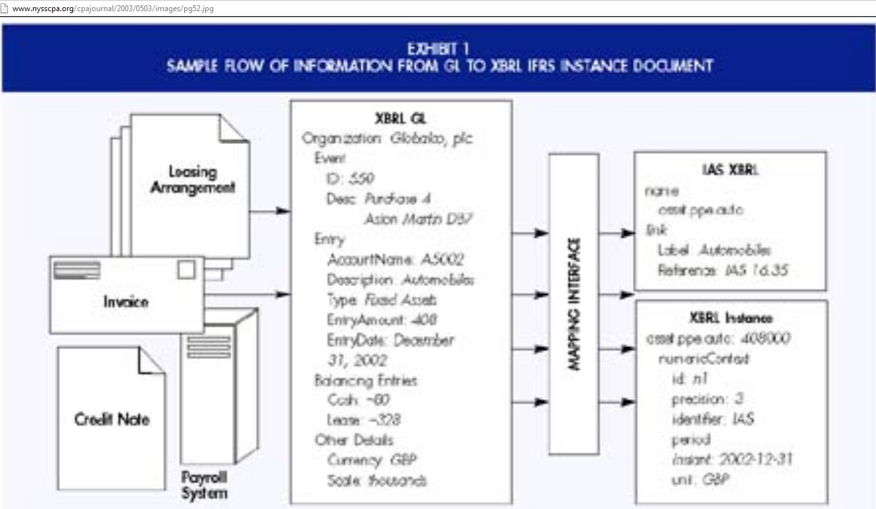

*There are two key points related to these data aggregations. First, the original data (within the ERP system) has an original context. The left side of*[*Exhibit 1*](javascript:WinOpen('../images/pg52.jpg','PicWin',450,260))*illustrates several events that need to be measured and recognized. A leasing arrangement will give rise to several entries. For example, event #550 was the purchase on December 31, 2002, of four cars costing $102,000 each. The cash outflow totals $80,000 and the remaining $328,000 is a credit to lease obligations. The context includes an identifier (event #550, a purchase of tangible fixed assets), a medium of exchange for the acquisition (cash and payables), and the value of the acquired assets ($408,000) at a point in time (December 31, 2002). Typically, as these data move through the corporate reporting supply chain, they lose most of their original context, which makes it difficult to trace them back to their sources. XBRL retains as much of the original context as is desired. The ability to rearrange information in a manner more suitable to the data consumer (analyst, banker, auditor, management) results in information that is significantly more valuable*.

In many ways we are trying to get in that area on Exhibit 1 above as Mapping Interface.

Exhibit 2

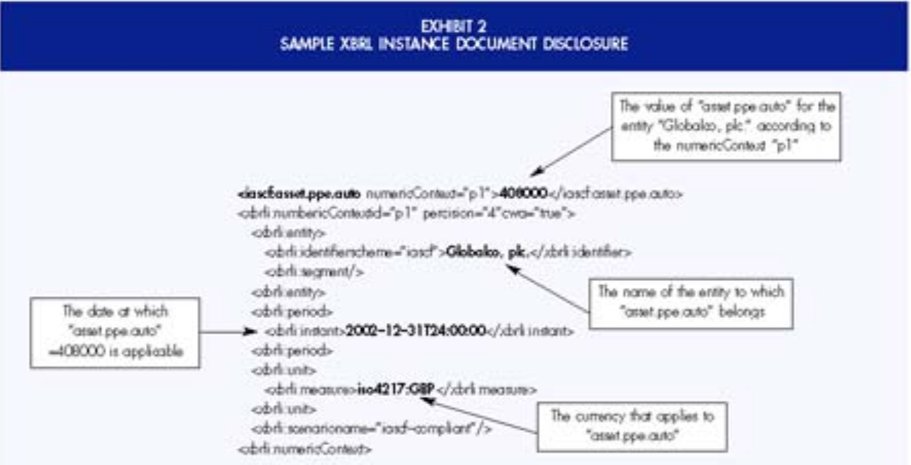

Second, information that is tagged can be interpreted and analyzed more easily. XBRL tags are designed to carry contextual information with them ([Exhibit 2](javascript:WinOpen('../images/pg54.jpg','PicWin',450,268))). XBRL IFRS tags carry not only the values related to IFRS concepts, but also each concept’s reference (to the 2002 IAS Bound Volume) and labels (both short and descriptive) in multiple languages.